SIMATS ENGINEERING

ASSESSMENT TOOL 3

COURSE NAME: COMPUTER NETWORKS COURSE CODE: CSA07

COURSE OUTCOME COVERED
CO2: Configure IP addressing schemes, subnetting, and basic routing techniques using simulation tool, for efficient network design and topology. (BL3)
Assessment Tool Weightage: 30% Software:Cisco Packet Tracer,Wireshark

QUESTIONS: 5 Total Marks:50

Annexure A

Debugging & Optimisation Task

Code of Conduct:

I S.JAGADESH(192421406) certify that this submission is my original work and that I have adhered to the guidelines specified for this assessment.
I understand that any violation of academic integrity rules will result in disciplinary action.

Signature of the student:

Annexure A

Debugging & Optimisation Task
- A network administrator has configured a workstation with the following settings:

  - IP Address: 192.168.10.65
  - Subnet Mask: 255.255.255.192 (/26)
  - Default Gateway: 192.168.10.1

However, the workstation is unable to communicate with other systems configured in the subnet 192.168.10.0/26.

Task

Debug the network configuration by:

  - Identifying the subnet to which the configured IP address belongs.
  - Determining the network address, broadcast address, and valid host range.
  - Verifying whether the configured IP address and gateway are valid.
  - Identifying the configuration errors.
  - Optimizing the configuration by assigning an appropriate IP address and default gateway.
  - Calculating the total number of usable host addresses after correction.

- Two devices are configured with the following IPv6 addresses:

  - Device A: 2001:db8::ff00:42:8329/64
  - Device B: 2001:db8:0:0:1::1/64

Although both devices are connected to the same network, communication fails.

Task

Debug the IPv6 configuration by:

  - Expanding both IPv6 addresses into their complete notation.
  - Determining the network prefix of each device.
  - Verifying whether both devices belong to the same subnet.
  - Identifying the addressing or prefix mismatch.
  - Optimizing the IPv6 configuration by assigning appropriate addresses.
  - Calculating the number of available host addresses within the corrected subnet.

- An organization has allocated the network 192.168.1.0/24 into several departments using the subnet masks /26, /27, and /28. Some departments report insufficient IP addresses, while others have a large number of unused addresses.

Task

Analyze and optimize the subnet allocation by:

  - Identifying the network address, broadcast address, and host range for each subnet.
  - Calculating the number of usable and unused IP addresses.
  - Identifying inefficient subnet allocations.
  - Debugging the addressing plan by locating subnet allocation mistakes.
  - Recommending an optimized subnetting scheme using VLSM to improve address utilization while supporting current departmental requirements.

- Two devices are configured with the following IPv6 addresses:

  - Device A: 2001:db8::ff00:42:8329/64
  - Device B: 2001:db8:0:0:1::1/64

Although both devices are connected to the same network, communication fails. Task
Debug the IPv6 configuration by:

  - Expanding both IPv6 addresses into their complete notation.
  - Determining the network prefix of each device.
  - Verifying whether both devices belong to the same subnet.
  - Identifying the addressing or prefix mismatch.
  - Optimizing the IPv6 configuration by assigning appropriate addresses.
  - Calculating the number of available host addresses within the corrected subnet.

- A router contains the following routing table.

Destination Network Next Hop
192.168.1.0/24 10.0.0.2
192.168.2.0/24 10.0.0.3
Default Route 10.0.0.1
Users report that packets destined for 192.168.2.100 are not reaching the intended network. Task
Debug the routing configuration by:

- Identifying the matching routing entry using the longest-prefix match.
- Determining the next-hop router selected for packet forwarding.
- Verifying whether the destination IP belongs to the intended subnet.
- Identifying any routing configuration errors.
- Optimizing the routing table to improve packet forwarding efficiency.
- Identifying the route that will be used if no matching destination exists.

4TH QUESTION DEBUGGING AND OPTIMIZATION

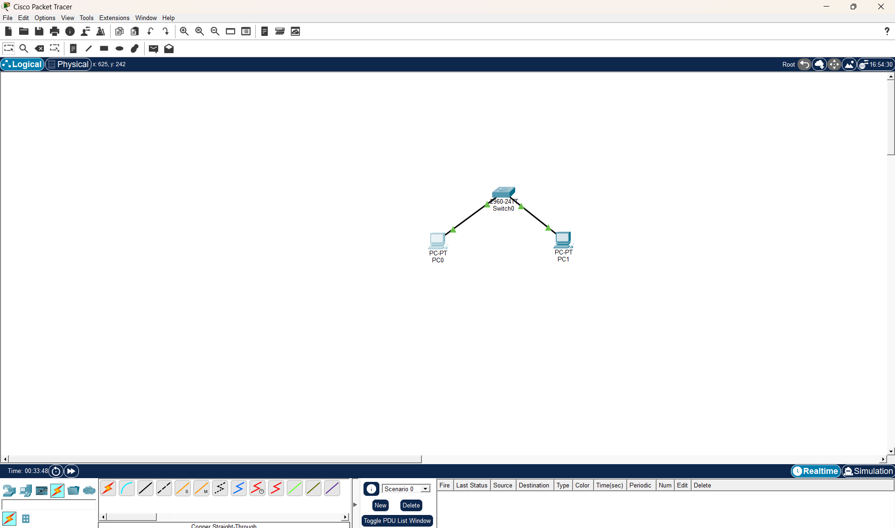

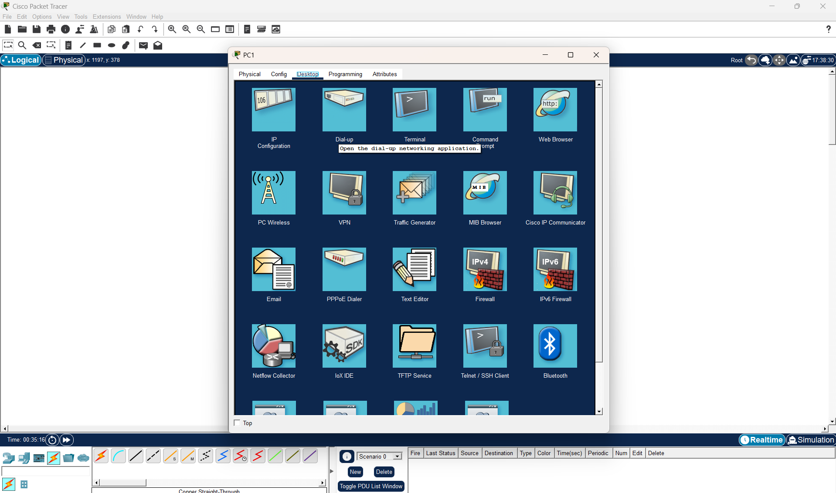

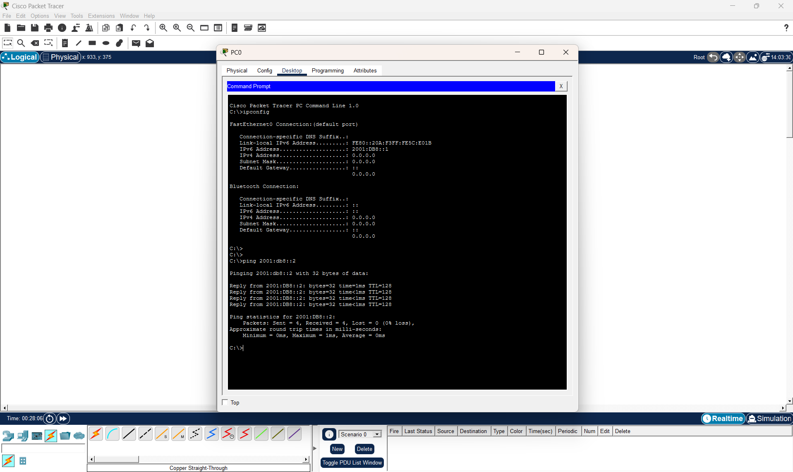

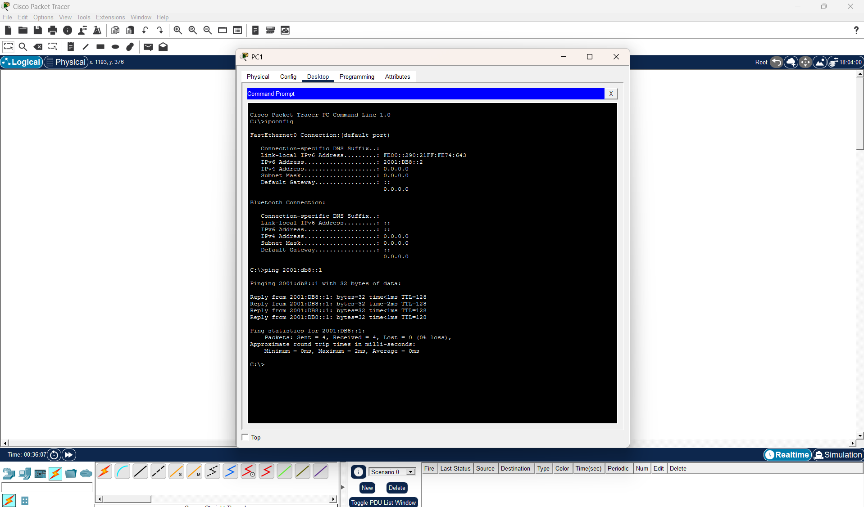

RUBRICS FOR CALCULATION

Criteria | Weightage | Level 4  (Exemplary) | Level 3 (Proficient  ) | Level 2  (Developing) | Level 1  (Beginning)
Problem Identification | 20% | Accurately identifies all errors and  root causes  with clear understandin g | Identifies most errors with minor gaps | Identifies some errors  but misses key issues | Unable to identify errors correctly
Debugging | 25% | Applies systematic debugging techniques effectively to  resolve issues | Uses appropriate debugging methods with minor  errors | Limited debugging approach; requires guidance | Unable to  debug or resolve issues
Optimization | 20% | Optimizes code by significantly improving time complexity using efficient algorithms | Improves time complexity with minor gaps in efficiency | Limited improvement in time  complexity | No improvement; inefficient approach retained
Analysis | 20% | Demonstrates strong logical reasoning and clear justification  of solutions | Shows reasonable analysis with some justificatio  n | Limited analysis; weak reasoning | No analytical reasoning demonstrated
Code Quality | 15% | Produces clean, well-structured code with proper comments and documentatio n | Code is mostly clear with minor documentat ion gaps | Code lacks structure and proper documentatio n | Poorly written code with no documentatio n

